Reading powershell history
C:\Users\<username>\AppData\Roaming\Microsoft\Windows\PowerShell\PSReadLine\ConsoleHost_history.txt
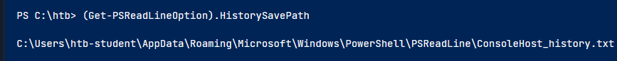

PS C:\htb> gc (Get-PSReadLineOption).HistorySavePath

Wevutil

foreach($user in ((ls C:\users).fullname)){cat "$user\AppData\Roaming\Microsoft\Windows\PowerShell\PSReadline\ConsoleHost_history.txt" -ErrorAction SilentlyContinue}

